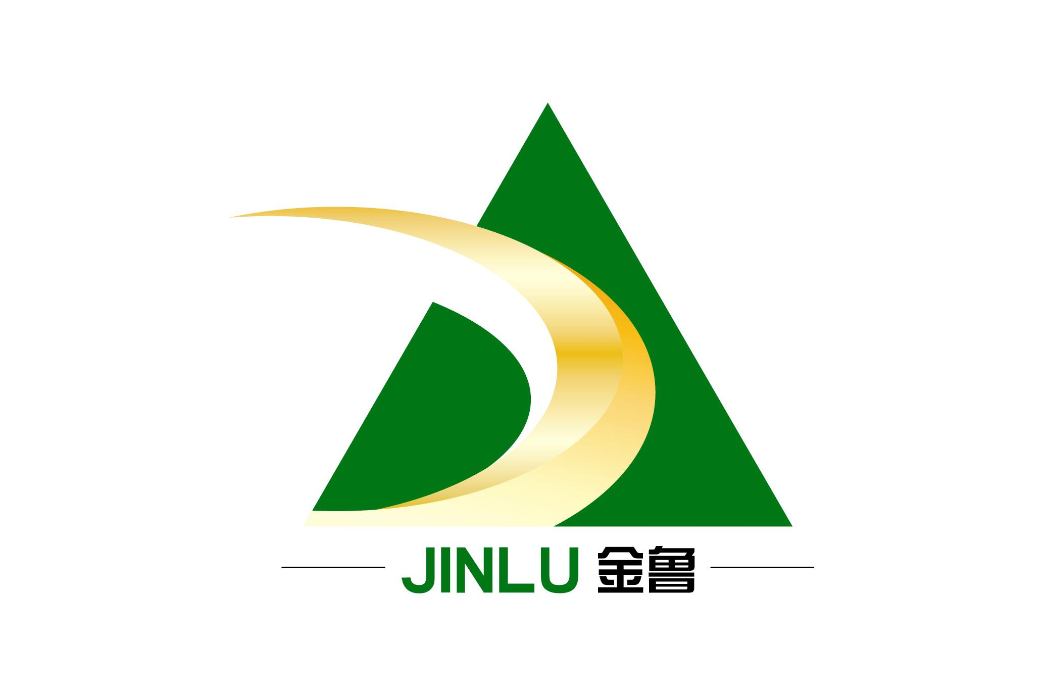
金鲁印染助剂系列
JIN LU YIN RAN ZHU JI XI LIE
丝光渗透剂 JL-120-2 penetrating agent JL-120-2
【一般性质】
化学组成: 低碳表面活性剂 component: low carbon surface active agent
离 子 性: 阴离子 Ionicity: cationic
外 观: 浅黄色黏稠液体 appearance:light yellow sticky liquid
水 溶 性: 易溶于水 solubility: easy dissolve in water
pH 值: 6-8 pH ：6-8
安 定 性: 耐强碱.耐高温.氧化剂 stability:resistance alkali,high temperature,oxygen agent
起 泡 性: 低泡 foam: low foaming
包 装: 120KG 塑料桶 packing:120 plastic drum
储藏安定性: 自出厂日起于密闭容器内和常温下可以储存12个月
Storing: sealed and normal temperature, keep 12 months
【应用技术资料】technical index
① 连续性加工 continuous product:
烧碱(100%)NaOH 240-250 克/升 g/L
丝光渗透剂penetrating agent 5-8 克/升g/L
工艺流程:浸轧→汽蒸→水洗→烘干process flow: pad→steam→washing→drying
浸 轧: 轧液率60% pad: pick up 60%
汽 蒸: 115℃±1℃ steam: 115℃±1℃
汽蒸压力: 1.1kg/ c m steam press: 1.1kg/ c m
水 洗: 水洗机使用前注意用水喷洗一次,使用60℃温水
Washing: use 60℃ warm water spray wash machine, before strat.
烘 干: 120-130 ℃ dyeing: 120-130 ℃
② 棉织物丝光加工cotton mercerized process:
烧 碱：240-300 克/升 NaOH: 240-300g/L
丝光渗透剂：6-15 克/升 penetrating agent : 6-15 g/L
https://www.chemicalbook.com/ProductNameList_25_9000_EN.htm

-sodium octyl sulfosuccinate: ngấm nhanh (rapid penetrate)
-Alkyl sulfonate content and fatty alcohol ethoxy compounds, anion: Lấy dữ liệu này viết sds
CAS number: 36445-71-3 Sodium alkyl (sulfophenoxy) benzene sulfonate 5-15%
CAS number: 68584-24-7 Alkylbenzene Sulfonate: 3-10%
CAS number: 7320-34-5 Tetrapotassium Pyrophosphate: 3-10 %
CAS number: 84133-50-6 Alcohol Ethoxylate: 3-10%

Penetrating Agent T Ot 70 Cas No. 1639-66-3
General
Appearance: Coloueless to yellowish liquid
Chemical Name: osmotic agent OT
Synonyms: Penetrating agent T; Aerosol OT; di-secovtyl naleate; Sodium di-n-octyl sulfosuccinate
Molecular Formula: C₂₀H₃₇NaO₇S
Molecular Weight: 444.56
Molecular Structure:
CAS No.: 1639-66-3
Applications
1.Soluble in water, milky white solution, resistant to strong acid, strong alkali, heavy metal salt and reducing agent.It has good wetting, permeating, emulsifying and foaming properties.The best infiltration effect is under 40℃, and the fabric is easy to be hydrolyzed when exposed to alkali at high temperature. Therefore, the fabric is suitable to be treated with permeant before heating up at 40℃.Osmotic agent T is not resistant to strong alkali, and cannot be directly added to concentrated alkali solution. The osmotic agent T should be added after the alkali solution is diluted first.
2.This product is a highly effective penetrant, which is used to treat cotton, hemp, viscose and its blended products.The slurry had better be cleaned in advance to ensure the permeation effect.
3.Used for raw cotton dyeing;Used for wettable powder of pesticide.

Antistatic Agent Sn Cas No. 86443-82-5
Chất ngấm làm giảm sức căng bề mặt giữa dầu và nước

